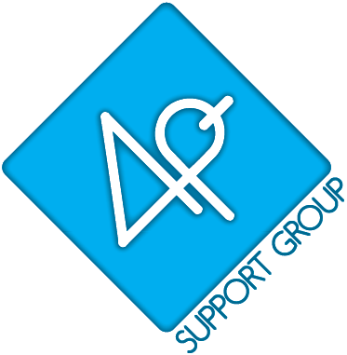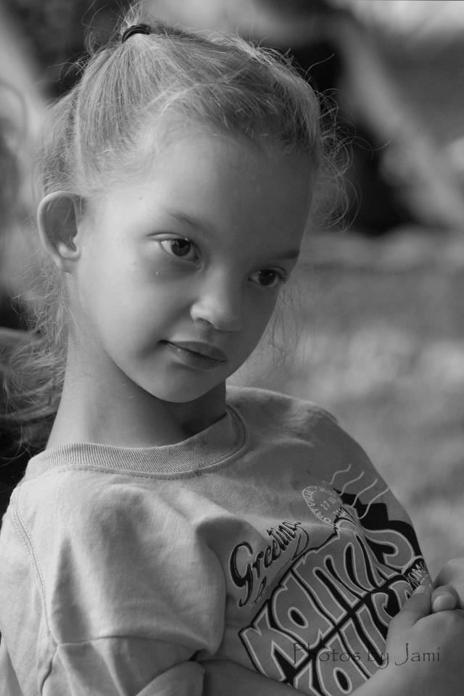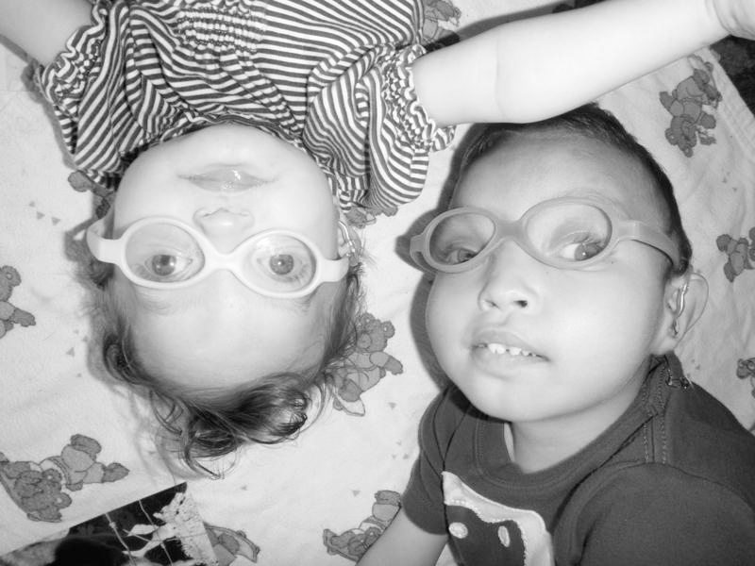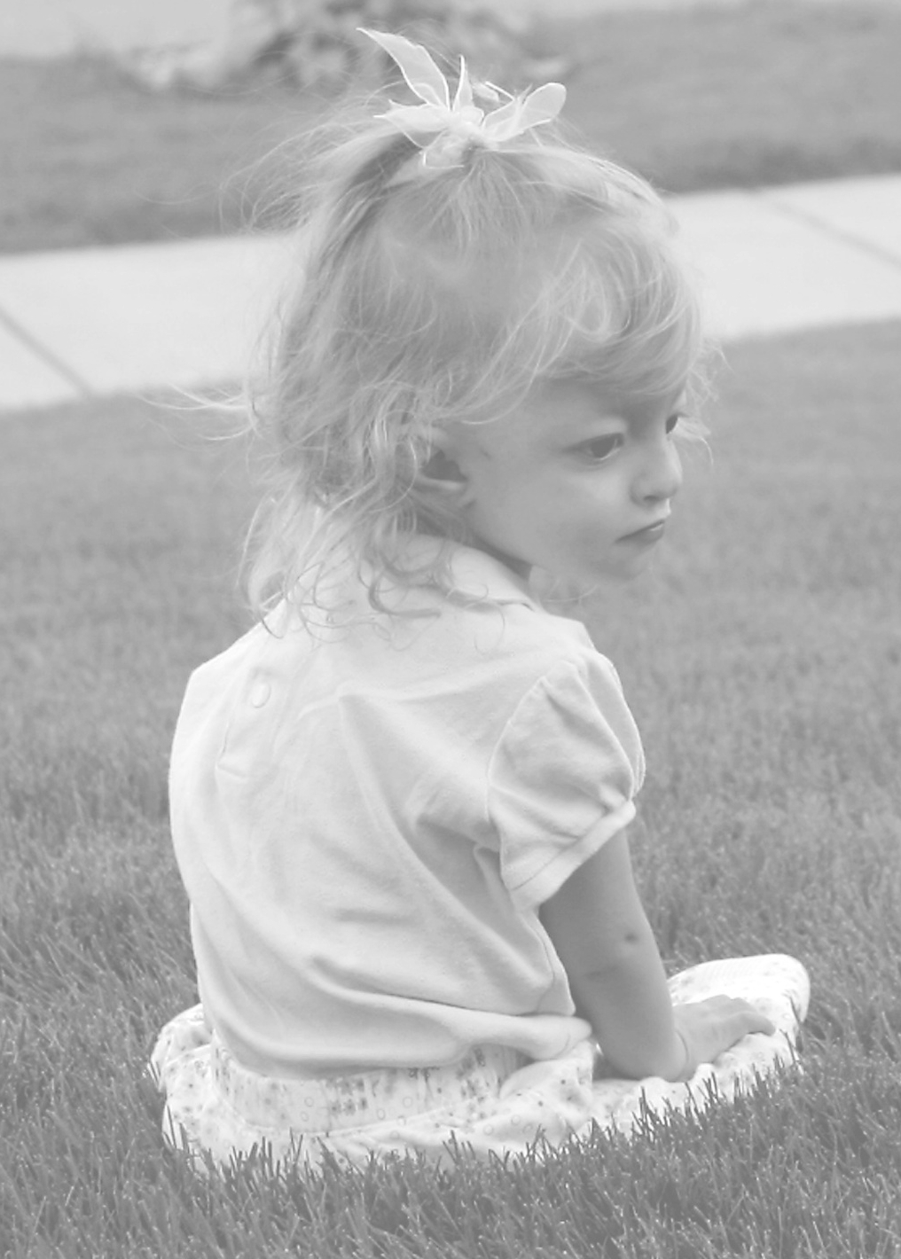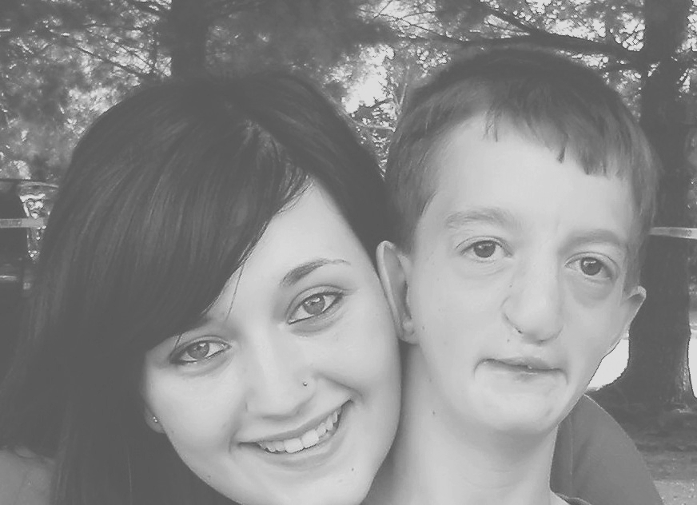

4p-supportgroup.org

[ENTER DATE HERE, 2014]
Dear [OFFICE MANAGER’S NAME],
As you may know I have a [DAUGHTER/SON] named [ENTER CHILD’S NAME]. What you may not know is that [ENTER CHILD’S NAME] is [ENTER CHILD’S AGE] and has a very rare genetic disorder called 4p- syndrome (also referred to as Wolf-Hirschhorn Syndrome).
4p- syndrome is due to a chromosomal deletion which is the cause of typical facial features and developmental delays. The anomalies are due to the lack of chromosomal material from the top of one of the number 4 chromosomes. This results in missing genes which account for the anomalies. The amount of material deleted may range from about 50% of the short arm to a small break that can’t be detected by normal chromosome analysis. In 10-20% of the cases the deletion can occur as a result of a translocated chromosome in the parent. Because of this wide range of deleted material, the effect on our children varies widely. Some can walk, talk and assist in their daily care while others are not verbal and require constant care. Some are near normal height and weight while others at ages 20-30 weight only 35-50 lbs and are only 45-55 inches tall. The medical involvement also varies from near normal to severe heart issues, complex seizures, gastrointestinal issues and renal insufficiencies, just to name a few. However, a common trait seems to be that our children are (for the most part) happy, loving children. We have some sayings in our group; “never say never”, “let your child show you what they can do” and “everything is in their own timing”. There are many other aspects to this syndrome, some of which we are still learning (for more information about 4p-, visit www.4p-supportgroup.org ).
We estimate 4p- syndrome occurs 1 out of every 50,000 births, with an estimate that 30% die within the first few years of life. However, we are beginning to see that rate decrease due to advances in medical technology and community awareness. A blood withdrawal for a DNA test is all that is needed for a diagnosis. However, if the patient has a small amount of missing material of the 4th chromosome more advanced DNA testing may be needed. 4p- syndrome has no cure.
4p- Syndrome Awareness Day which is held on April 16th was established by the 4p- Support Group, a non-profit organization and the only national organization to support those living with and affected by 4p- syndrome through every stage of life, to focus the spotlight on this genetic disorder. I am contacting you to see if we could arrange something special on April 16th to recognize 4p- Syndrome Awareness Day and [ENTER CHILD’S NAME]. I am open to suggestions on what may work for our office and staff. A couple ideas I have are having a [EXAMPLE: jeans day]. This day is to focus on awareness however if there is a potential to do an optional donate spare change or $1 to participate, please know that the 4p- Support Group is a registered 501(c)3 organization. Money raised goes towards support services for families like mine who have a child with 4p- and include but are not limited to biennial conferences, welcome informational packets to newly diagnosed families, regional gatherings, facilitation of annual Scientific Meetings, promoting research and funding the 4p- International Registry.
I would appreciate the opportunity to talk to you more about this to see if recognizing 4p- Awareness Day at [COMPANY’S NAME] is a possibility. I can be reached at [ENTER PHONE NUMBER] or [ENTER EMAIL ADDRESS].
Sincerely,

[ENTER YOUR NAME HERE]

Tax I.D. #91-2005528

